**VNM SHIFTER V1**

**USER MANUAL**

**VNM SHIFTER USER MANUAL**

**Contents**

**1.** **Installation** 3

**2.** **RUN/DFU Modes** 3

**3.** **H-pattern/Sequential working mode** 4

**4.** **Connection** 4

**5.** **Shifter Configurator UI** 4

**5.1. Download VNM Configurator** 4

**5.2. VNM Configuration Overview** 7

**5.3. Led Configuration** 8

**5.4. Shifter Calibration** 9

**5.4.1. H-pattern Calibration** 9

**5.4.2 H-pattern threshold setup** 10

**5.4.3. Calibrate sequential** 11

**5.4.4 Sequential threshold setup** 11

**6. Firmware Update** 12

# **Installation**

Check [VNM Shifter V1 – Quick Guide](https://github.com/vnmsimulation/shifter/blob/main/Shifter%20Hardware%20Manual.pdf) for installation instruction.

# **RUN/DFU Modes**

The VNM Shifter supports both manual H-pattern and Sequential shifting modes. Change working modes by changing the Shifter Mode switch position located on the left side of the rear panel of the shifter (circled RED in the picture below), then swapping to the appropriate shift pattern plate (or vice versa).

* When switched to the left 🡺 The shifter is in Sequential mode.
* When switched to the right 🡺 The shifter is in H-pattern mode

VNM Shifter has 2 modes:

* RUN mode: VNM Shifter acts as a HID device to work as a gear selector (shifter) in supported games and applications
* DFU mode: it acts as DFU device to facilitate firmware upgrade

These modes can be selected using the RUN/DFU switch at the back of the device (circled RED in the picture below).

* When switched to the left 🡺 The shifter is in RUN mode.
* When switched to the right 🡺 The shifter is in DFU mode

# **H-pattern/Sequential working mode**

The VNM Shifter supports both manual H-pattern and Sequential shifting modes. Change working modes by changing the Shifter Mode switch position located on the left side of the rear panel of the shifter (circled RED in the picture below), then swapping to the appropriate shift pattern plate (or vice versa).

* When switched to the left 🡺 The shifter is in Sequential mode.
* When switched to the right 🡺 The shifter is in H-pattern mode

# **Connection**

Two connection ports are available:

* Bottom USB port (Red): Connect VNM Shifter to PC
* Top USB port (Blue): Connect Truck Knob to VNM Shifter (future optional accessory)

# **Shifter Configurator UI**

## **5.1. Download VNM Configurator**

The **VNM Configuration software** is used to configure, calibrate and customize every product in the VNM Simulation ecosystem, including the VNM Shifter.

* 1. A screenshot of a website

     AI-generated content may be incorrect.Download at [Download Software - VNM Simulation., JSC](https://vnmsimulation.com/download/).
  2. Choose either User Interface **Stable Version** or **Beta version**. The **Stable version** is recommended. **The Beta version** can include experimental features and new UI elements but there may be bugs or issues that can impact the use of the product. Use the **Beta version** at your own risk.
  3. Open the downloaded .ZIP file



* 1. Extract VNMConfig.exe and launch the extracted VNMConfig.exe file.
     1. We recommend creating a new folder for VNMConfig.exe because upon launching the executable file for the first time, the folder in which VNMConfig.exe is located will be populated with data files and supplementary folders. Doing so ensures better file management for ease of access.

* 1. If your computer doesn’t allow you to launch the executable, right click on VNMConfig.exe 🡪 Properties

* 1. Click **Unblock** button and launch VNMConfig.exe again.

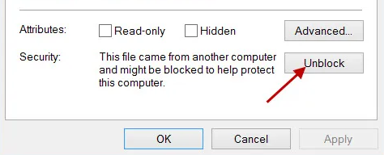

## **5.2. VNM Configuration Overview**

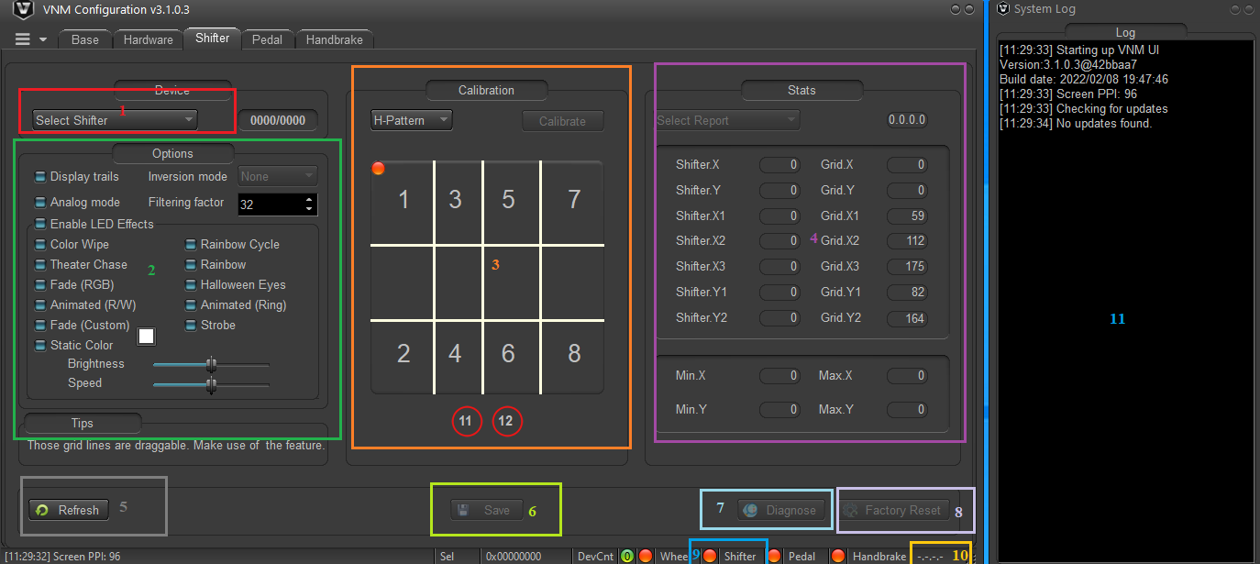Note: VNM Configuration Software UI may differ slightly between versions.) to configure your VNM Shifter.

1. Choose the shifter that you want to configure (software will auto-detect the device)

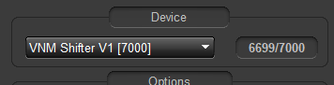

1. Options area: You can configure the LED color, enable/disable LED illumination and some internal parameters of the VNM Shifter (internal of shifter must not be changed unless a recommendation from the manufacturer or distributor has A screenshot of a computer

   AI-generated content may be incorrect.been issued).
2. The **Calibration** area: The grid is for calibration and gear threshold setup.
   * 1. Click the **Calibrate** button to start the **Calibration Wizard**, then follow the instruction on screen to calibrate your VNM Shifter
     2. After the calibration process is completed, you can click and move the lines to more accurately define the detection area for each gear.
3. The **Stats** area shows internal parameter when calibrating.
4. The **Refresh** button is used to get the current parameters of the VNM Shifter.
5. The **Save** button sends and saves the current settings to the VNM Shifter.
6. The **Diagnose** button is used to troubleshoot communication between the VNM Shifter and VNM Configuration app
7. The **Factory Reset** button resets all settings to default factory settings.
8. The **Shifter status** dot will turn green when the VNM Shifter is in RUN mode and connected to PC and turn orange if the VNM Shifter is DFU mode or not connected to PC.
9. The **Firmware Version** area shows the current firmware version of the VNM Shifter.
10. The **System Log** window records and displays the communication status between the VNM Shifter and VNM Configuration app.

## **5.3. Led Configuration**

* 1. Check/uncheck “Enable LED Effects” checkbox to enable/disable LED illumination of the “V” logo at the front of the VNM Shifter.

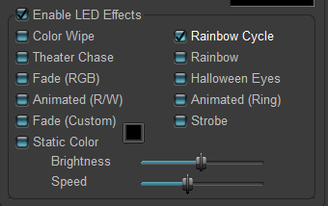

* 1. You need at least one effect selected when you enable the LED (if static color is chosen, the front “V” LED only lights up the chosen static color).
  2. You can change the brightness and speed of effects by adjusting the Brightness and Speed sliders.
  3. Fade (custom):
     1. Left click the square button (1) to choose a new color.
     2. A pop-up is displayed allowing you to choose available color presets in (2).
     3. If your desired color is not found in the list of presets, click the **Eyedropper** button (3) to select any color on your screen, which will then add that color to the list of presets.
     4. Or, choose a color in the color chart in (4) to further personalize your selection. After choosing a color, click the **OK** button in the popup to save your settings.
  4. Click **Save** button after you have configured your LED effects.

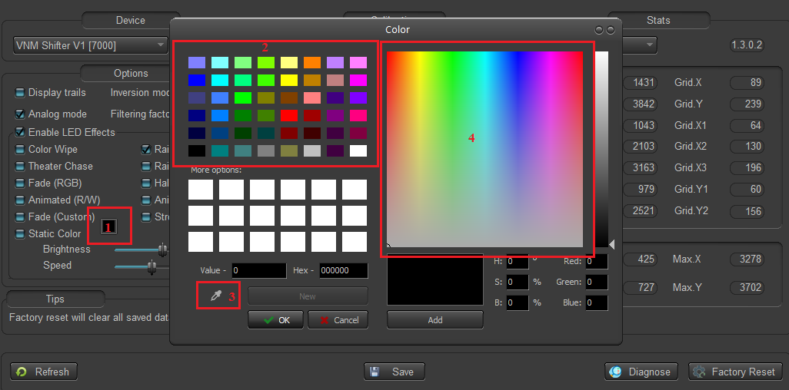

## **5.4. Shifter Calibration**

Note: H-Pattern mode and Sequential mode must be calibrated separately.

### **5.4.1. H-pattern Calibration**

**H-pattern Shifter Calibration** is used to determine the min-max values of the X and Y axis. This process is only necessary after installing new firmware or after a factory reset is performed.

* **Step 1:** Install the **H-pattern plate** onto the shifter and change the **H-pattern/Sequential switch**’s position to the right (H-pattern mode)
* **Step 2:** Click **Calibrate** button, which will prompt it to turn into Finish. An instruction popup is displayed. Read the instruction carefully, then click **OK** button.
* **Step 3:** Move the shifter rod to every gear gate on your VNM Shifter at a steady pace. It is recommended to steadily go through all shifter gates **at least 3 times** for maximum accuracy.
* **Step 4:** Click **Finish** when you are done.
* **Step 5:** click **Save** to save your calibration information to the VNM Shifter’s ROM (or onboard memory)

### **5.4.2 H-pattern threshold setup**

* **Step 1:** Install the **H-pattern plate** onto the shifter and change the **H-pattern/Sequential switch**’s position to the right (H-pattern mode)
* **Step 2:** Check the “**Display trails**” checkbox in the **Options** area to display the shifter rod’s position in real-time
* 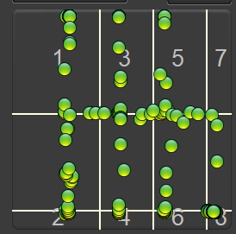**Step 3:** Move the shifter rod to each gear gate. The trail will be visualized on the grid like this:
* **Step 4:** Drag/drop the vertical and horizontal white lines such that when the shifter is in a physical gear position, the green dot does not overlap any white line. Allowing any overlap will cause the VNM Shifter to 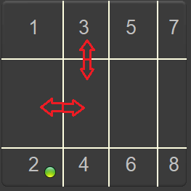incorrectly register gears.
* **Step 5:** Click **Save**
* **Step 6:** Test again to make sure all gear position work.

### **5.4.3. Calibrate sequential**

**Sequential pattern Shifter Calibration** is used to determine the min-max values of the Y axis. This process is only necessary after installing new firmware or after a factory reset is performed

* **Step 1:** Install the **Sequential pattern plate** onto the shifter and change the **H-pattern/Sequential switch**’s position to the left (Sequential mode)
* **Step 2:** Check the “**Display trails**” checkbox in the **Options** area to display the shifter rod’s position in real-time
* **Step 3:** Move the shifter forward and backward at a steady pace. It is recommended to repeat this step **at least 3 times** for maximum accuracy.
* **Step 4:** Click **Finish** when you are done.
* **Step 5:** click **Save** to save your calibration information to the VNM Shifter’s ROM (or onboard memory)

### **5.4.4 Sequential threshold setup**

* **Step 1:** **Step 1:** Install the **Sequential pattern plate** onto the shifter and change the **H-pattern/Sequential switch**’s position to the left (Sequential mode)
* **Step 2:** Check the “**Display trails**” checkbox in the **Options** area to display the shifter rod’s position in real-time
* **Step 3:** Move the shifter rod forward and backward. The trail will be visualized on the grid similar to what’s shown above for H-pattern
* A screenshot of a video game

  AI-generated content may be incorrect.**Step 4:** Drag/drop the horizontal white lines such that when the shifter is in at forward-most or backward-most positions, the green dot does not overlap any white line. Allowing any overlap will cause the VNM Shifter to incorrectly register gears.
* **Step 5:** Click **Save**
* **Step 6:** Test again to make sure all gear position work.

# **6. Firmware Update**

1. Download latest firmware at [Download Software - VNM Simulation., JSC](https://vnmsimulation.com/download/).
2. How to upgrade: Check the manual of the update tool in the download page above.

If you have any questions, please contact with your distributor or contact us by sending an email to sale@vnmsilumation.com.